* In case of an element having two classes defining same attribute (for example color), the class that is defined later in the css file will be used.
* We can combine selectors, for example a.active means select all anchor tag with active class name.
* We can link in page element (same as linking other pages) by id. Simply put a section id in the href and clicking it will go to that section.

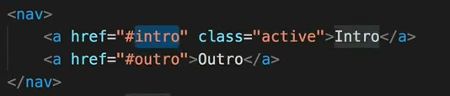

* !important is a special feature of css, if we use it after a css attribute. It will overwrite all specifity. It is recommended to not use this.
* Inherit is another property which makes element prioritize inherited property rather than default one. One example is when we customize button css, there is some default button properties. They overwrite the font-family that we define.
* To make a perfect circle with a div, we need to define same height and width for the class, then set border-radius to 50%.